LASD Field Support Bureau — Kiro Workshop
Attendee setup guide — Wednesday, September 23, 2026
Amazon Irvine SNA16, room 01.105 (Arctic)
Read this first
- The Kiro lab runs on Kiro's free tier. You sign in with an AWS Builder ID, which is a free personal profile. You do NOT need an AWS account for it, you will not create any cloud resources, and there is nothing to pay.
- You need a laptop you can install software on. Windows, macOS, and Linux all work. If your laptop blocks software installs, tell the instructor now — you can still follow along on screen.
- You also have a paper slip with a username (like lasd07) and a one-time password. That is the FALLBACK. Use it only if the Builder ID route fails, or if you run out of free credits during the day. See “If Builder ID does not work for you” below.
- Steps 1 and 2 are enough to start the workshop. Steps 3 to 7 are for the Claude Code session at 12:55 PM — you can do them over lunch.
This is a temporary practice environment. Do not put any Sheriff's Department data, case information, or real source code into it.
Where to type the commands in this guide
Several steps ask you to run a command. Here is where you type it:
Windows | Click Start, type PowerShell, press Enter. A blue window opens with a prompt starting PS C:\
macOS | Press Command+Space, type Terminal, press Enter.
Linux | Open your usual terminal application.
Type the command exactly, then press Enter. If a command is not recognised right after you install something, close the window and open a new one — that reloads the list of available commands.
Step 1 — Install Kiro
- Download Kiro from https://kiro.dev/downloads and install it. There are builds for Windows, macOS and Linux. On Windows, run the downloaded installer; on macOS, drag Kiro to your Applications folder.
- Open Kiro once and confirm you reach the welcome screen. Leave it open — you sign in next.
Kiro is a few hundred megabytes, so start this download first and read Step 2 while it runs.
Step 2 — Sign in with an AWS Builder ID
This is the method the workshop itself uses. An AWS Builder ID is a free personal profile — it is separate from any AWS account, and on the free tier Kiro costs nothing.
- At Kiro's sign-in screen choose AWS Builder ID.
- Your browser opens. If you already have a Builder ID, enter that email and password. If not, choose to create one: enter an email address you can read on this laptop, then type the verification code AWS emails you, and set a password.
- Approve the request for Kiro, then return to Kiro. You should land in the IDE signed in.
Do not use a Sheriff's Department case-management or evidence email address for this. A work email is fine; a personal one is fine too.
On the free tier you get 50 credits per month, and access to Claude Sonnet 4.5 plus several open-weight models. That is enough for this workshop. If you run out part-way through, switch to the paper slip below — do not pay for anything.
One thing worth knowing, because it matters to this organisation: Kiro's documentation states that content from free-tier and individual accounts may be used for service improvement, with an opt-out available. Enterprise sign-in (the paper-slip route) is not treated that way. For today it makes no difference — you are building a game from a public starter kit — but do not paste real LASD code into Kiro on a free-tier Builder ID.
If Builder ID does not work for you — use the paper slip
Three things commonly stop a Builder ID being created in a room like this: you cannot receive the verification email on that laptop; AWS asks for extra verification because a dozen people are signing up from one address at once; or your laptop filters the sign-up domains. Any of those, stop and use this instead. It needs no email and no verification code.
This route signs you in to an AWS account we prepared for this session, and it carries Kiro Pro Max rather than the free tier, so credits will not run out.
- Open this address in a browser: https://d-90667e4749.awsapps.com/start
- Type the username from your slip and click Next.
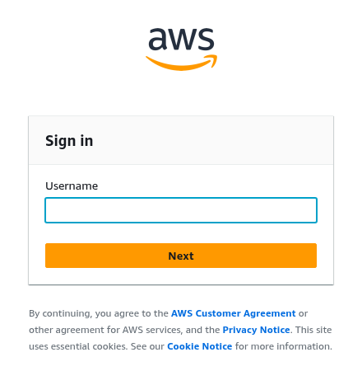
The sign-in page. Enter your username only here.
- Type the one-time password from your slip and click Sign in. Leave "This is a trusted device" unticked.
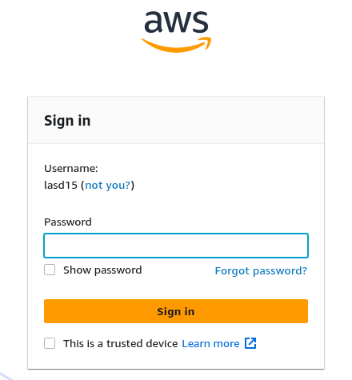
The password page. Your username is shown above the box.
- You are required to choose your own password. Enter it twice — the page shows "Match" when the two agree — then click Set new password.
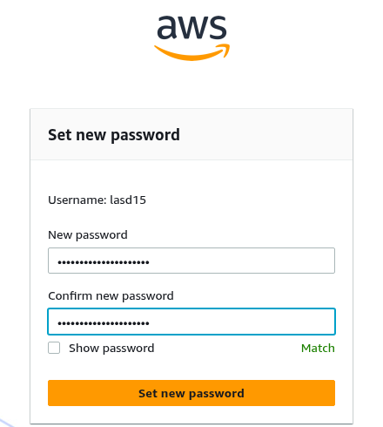
Setting your own password. It needs at least 8 characters with upper case, lower case, a number and a symbol.
Write your new password down. You need it again when you sign in to Kiro and in Step 4, and nobody can look it up for you.
- You land on the AWS access portal. The Accounts tab lists one account. Click the account name to expand it and you will see the role you use, LASDWorkshopBedrock.
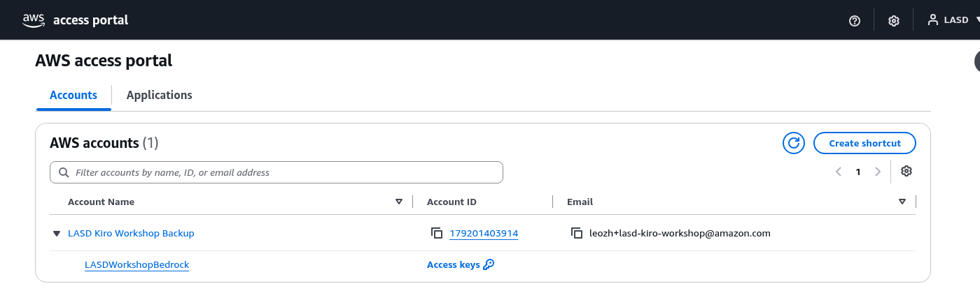
The Accounts tab, expanded. Account 179201403914 with the LASDWorkshopBedrock role.
- Click the Applications tab. Kiro is listed there, which confirms your Kiro licence is active.
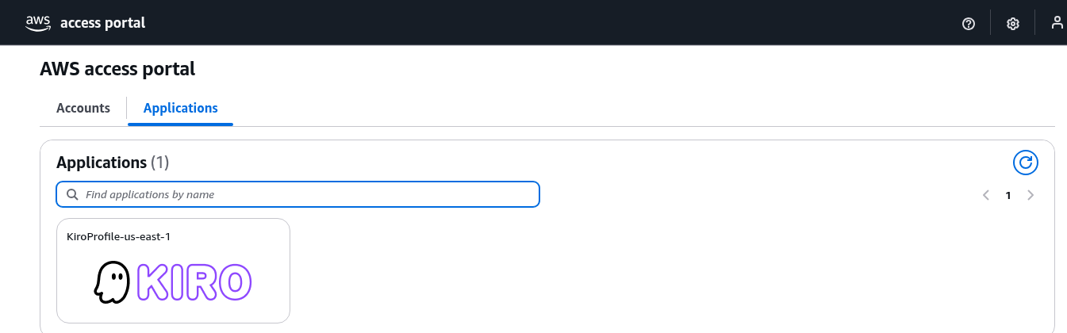
The Applications tab. KiroProfile-us-east-1 means your Kiro licence is assigned.
If the sign-in page does not load at all, try the alternate address:
https://ssoins-7223c4f91f99f0d8.portal.us-east-1.app.aws
Then point Kiro at it
If you had already signed in to Kiro with a Builder ID, sign out first: open the Command Palette and run Kiro: Sign Out.
- At Kiro's sign-in screen choose AWS IAM Identity Center — not Builder ID, Google or GitHub, because those go back to the free tier.
- Enter these two values when prompted:
Start URL: https://d-90667e4749.awsapps.com/start
Region: us-east-1
- A browser window opens. Sign in with your username and the password you just set, then approve the request and return to Kiro.
On this route your licence is Kiro Pro Max. If Kiro says you have no subscription, tell the instructor rather than signing up personally.
Can't install software? Use the provided Windows desktop instead
For the 12:55 PM Claude Code session only, the workshop provides a ready-made Windows desktop that you reach from your browser. Claude Code, Claude Cowork, Visual Studio Code, Git, Node.js and the AWS CLI are already installed on it, and its Bedrock access configures itself. If your laptop will not let you install software, take this route and skip Steps 3 to 7 entirely.
- Ask the instructor for the DCVUrl, DCVUsername and DCVUserPassword values. They are published as Event Outputs on the workshop-windows-desktop stack.
- Open the DCVUrl in your browser. It is an HTTPS address on port 8443.
- Your browser will warn you that the certificate is not trusted. That is expected — the desktop uses a self-signed certificate. Choose Advanced, then the “Proceed to … (unsafe)” link.
- Sign in with DCVUsername (Administrator) and DCVUserPassword. You land on a Windows desktop; a Visual Studio Code shortcut opens the workshop folder.
- Look on the desktop for a file called workshop-setup-OK.txt. When it appears, Claude Code is configured and signed in, and you can go straight to the verify step. It can take up to 15 minutes to show up, because the desktop keeps installing in the background after it becomes reachable.
If you see workshop-setup-FAILED.txt instead, or neither file after about 15 minutes, sign out and back in to retrigger it. If it still does not appear, tell the instructor — the setup script can be run by hand.
Two things to know. The remote desktop has its own clipboard, so text you copy on your own machine will not paste straight in — use the clipboard icon in the toolbar at the top left to open the Copy and paste panel, which you will need all session. And the desktop needs TCP and UDP port 8443: if the building network blocks those, this route will not connect and you should use your own laptop.
Claude Cowork still needs its one-time configuration import, which the workshop walks you through either way.
Step 3 — Install the AWS CLI
Steps 3 to 7 are for the Claude Code session at 12:55 PM, not for the Kiro lab. The Kiro lab needs no AWS account at all. Do these over lunch if you can — or skip them all by using the Windows desktop described above.
The AWS CLI is what gives Claude Code and the Agent Toolkit permission to talk to AWS. Check whether you already have it:
aws --version
You want version 2.35 or newer. If you see something like aws-cli/2.33.15, it is too old for Step 6 — install the current version over the top using the instructions below. If you see "command not found" or "not recognized", it is not installed yet.
Windows
- Download https://awscli.amazonaws.com/AWSCLIV2.msi
- Double-click the downloaded file and click through the installer, accepting the defaults.
- Close PowerShell and open it again, then run: aws --version
macOS
- Download https://awscli.amazonaws.com/AWSCLIV2.pkg
- Double-click it and click through the installer. You will be asked for your Mac password.
- Open a new Terminal window and run: aws --version
If you already use Homebrew, brew install awscli works too.
Linux
curl "https://awscli.amazonaws.com/awscli-exe-linux-x86_64.zip" -o "awscliv2.zip"
unzip awscliv2.zip
sudo ./aws/install
aws --version
Step 4 — Give the AWS CLI credentials
There are two ways to do this and the lab will tell you which one you are using. Read the short version first:
Easiest — from the lab page | In the Workshop Studio left-hand panel choose “Get AWS CLI Credentials”, pick your operating system, copy the block and paste it into your terminal. Nothing to configure. These expire when the event ends.
Fallback — the prepared account | Run the aws configure sso command below. Takes a couple of minutes, then lasts 12 hours. Use this if the lab page will not load, or if you are on the paper-slip route.
If you pasted credentials from the lab page, skip the rest of this step and go to Step 5.
Fallback — connect to the prepared account
Run this and answer the prompts. It is the same command on every operating system:
aws configure sso
Answer exactly as follows. Where a prompt offers a default in brackets you can press Enter to accept it only if it already matches this table.
SSO session name | lasd
SSO start URL | https://d-90667e4749.awsapps.com/start
SSO region | us-east-1
SSO registration scopes | sso:account:access
Account (if asked to choose) | 179201403914 (LASD Kiro Workshop Backup)
Role (if asked to choose) | LASDWorkshopBedrock
CLI default client Region | us-east-1
CLI default output format | json
CLI profile name | lasd
A browser window opens so you can approve the request — sign in if asked, then click Allow access. Back in the terminal, confirm it worked:
aws sso login --profile lasd
aws sts get-caller-identity --profile lasd
The second command should print account 179201403914 and a role name containing LASDWorkshopBedrock. If it prints an error about credentials, run the aws sso login line again.
Step 5 — Install Claude Code
Claude Code runs in the terminal. It does not need Node.js — the installer below downloads a self-contained program.
Windows (PowerShell)
irm https://claude.ai/install.ps1 | iex
If you get 'irm' is not recognized, you are in the older Command Prompt rather than PowerShell. Either open PowerShell, or run this instead:
curl -fsSL https://claude.ai/install.cmd -o install.cmd && install.cmd && del install.cmd
macOS and Linux
curl -fsSL https://claude.ai/install.sh | bash
Then check it
claude --version
That should print a version number. If anything looks wrong, claude doctor prints a diagnostic report without starting a session.
Step 6 — Install the Agent Toolkit for AWS
The Agent Toolkit gives your coding agent current AWS documentation and tested, step-by-step AWS skills, so it stops guessing at APIs from memory. It is free. One command sets it up and it detects Kiro and Claude Code for you:
aws configure agent-toolkit
This needs AWS CLI 2.35 or newer (Step 3). On an older CLI it fails with:
aws: [ERROR]: argument subcommand: Found invalid choice 'agent-toolkit'
The toolkit also needs a small helper called uv. If the command above complains that uv is missing, install it and run the command again:
Windows (PowerShell)
powershell -ExecutionPolicy ByPass -c "irm https://astral.sh/uv/install.ps1 | iex"
macOS and Linux
curl -LsSf https://astral.sh/uv/install.sh | sh
If you would rather set it up per tool
In Claude Code, type:
/plugin install aws-core@claude-plugins-official
/reload-plugins
For Kiro, add this to the file ~/.kiro/settings/mcp.json (create it if it is not there), then run the skills command below it:
{
"mcpServers": {
"aws-mcp": {
"command": "uvx",
"timeout": 100000,
"transport": "stdio",
"args": [
"mcp-proxy-for-aws@1.6.3",
"https://aws-mcp.us-east-1.api.aws/mcp",
"--metadata", "AWS_REGION=us-east-1"
]
}
}
}
npx skills add aws/agent-toolkit-for-aws/skills
What you can build with it here
Your workshop credentials can create real AWS resources — S3 buckets, Lambda functions, DynamoDB tables, API Gateway APIs, CloudFormation stacks, CloudWatch logs — so the toolkit's skills work end to end, not just its documentation search.
A few things are deliberately blocked so that one person cannot disrupt the workshop or run up a large bill. If your agent hits an "explicit deny" on any of these, it is the guardrail working, not a broken setup:
- Changing sign-in: Identity Center, the identity store, and AWS Organizations.
- Creating IAM users or access keys — credentials that would outlive the workshop.
- Large or GPU EC2 instance types, SageMaker endpoints and training jobs, Redshift clusters, EMR clusters, and Bedrock provisioned throughput.
- Turning off CloudTrail or GuardDuty.
Roles your agent creates must carry the LASDWorkshopBoundary permissions boundary. The agent normally handles this for you; if it reports that it cannot create a role, ask it to attach that boundary and try again.
Full toolkit documentation: https://docs.aws.amazon.com/agent-toolkit/latest/userguide/what-is-agent-toolkit.html
Step 7 — Point Claude Code at Bedrock
Do not set environment variables by hand. The workshop ships a setup script that does the whole job: it reads the workshop's CloudFormation outputs, signs you in to the workshop's Cognito user pool, and writes an AWS profile named workshop, your ~/.claude/settings.json with the right model IDs and telemetry, and a Claude Cowork configuration file for later.
You need two things first: the AWS CLI credentials from Step 4 working (aws sts get-caller-identity must succeed), and your Cognito username and password. Those two values are published as Event Outputs on the workshop-cognito stack — CognitoUsername and CognitoPassword. The instructor will show you where.
Windows (PowerShell)
irm "https://ws-assets-prod-iad-r-iad-ed304a55c2ca1aee.s3.us-east-1.amazonaws.com/3cc53475-900a-4801-bc5b-21ed15439675/laptop-setup/setup.ps1" -OutFile setup.ps1
powershell -ExecutionPolicy Bypass -File setup.ps1
macOS and Linux
curl -fsSL "https://ws-assets-prod-iad-r-iad-ed304a55c2ca1aee.s3.us-east-1.amazonaws.com/3cc53475-900a-4801-bc5b-21ed15439675/laptop-setup/setup.sh" -o setup.sh
bash setup.sh
The script prints the resources it found, then prompts for your Cognito username (an email address) and password. When it finishes it says to restart Claude Code.
What it sets up, and why there is no API key
There are no long-lived AWS keys on your laptop. The script installs a credential helper, and every time Claude Code needs Bedrock it signs in to Cognito, exchanges the token through AWS STS for temporary credentials, and calls Bedrock with those. They refresh on their own. Because they are minted per person, every request is attributed to you rather than to a shared key — which is the whole point of the session.
Primary model | global.anthropic.claude-sonnet-4-6
Small / fast model | global.anthropic.claude-haiku-4-5-20251001-v1:0
Heavy-reasoning model | global.anthropic.claude-opus-4-6-v1
AWS profile it creates | workshop
Files it writes | ~/.aws/config, ~/.claude/settings.json, ~/claude-cowork-config.json
All three models were tested in a real workshop account on the morning of the session and all three answered.
Check it
claude "What are the benefits of Amazon Bedrock?"
A sensible answer means Claude Code is installed, routed through Bedrock, and your credentials are good. If you get AccessDeniedException, your Cognito sign-in probably failed — re-run the script and retype the password.
Fallback — the prepared account instead
The setup script only works against the workshop's own account, because it looks up that account's CloudFormation stacks. If you are on the prepared account from the paper slip, there is no Cognito to sign in to, so configure Claude Code by hand instead. On macOS or Linux paste these; on Windows PowerShell use $env:NAME = "value" in place of export NAME=value.
export AWS_PROFILE=lasd
export CLAUDE_CODE_USE_BEDROCK=1
export AWS_REGION=us-east-1
export ANTHROPIC_DEFAULT_OPUS_MODEL='us.anthropic.claude-opus-5'
export ANTHROPIC_DEFAULT_SONNET_MODEL='us.anthropic.claude-sonnet-4-5-20250929-v1:0'
claude
Set both model lines. If you pin only the Opus one, Claude Code sends its small background tasks to Opus as well, which costs far more than it needs to.
Two differences on Bedrock either way: the web-search tool is unavailable, and /logout does nothing because AWS handles sign-in.
Reference: Claude Code on Amazon Bedrock
If something goes wrong
Kiro says "There was an error signing you in" | Sign out (Command Palette, Kiro: Sign Out) and try again. For the Kiro lab choose AWS Builder ID. Only if you are on the paper-slip route do you choose AWS IAM Identity Center, and then you must enter the Start URL exactly as printed.
Builder ID: no verification email arrives | Check spam, and check you can receive mail on this laptop at all. If it will not come through, switch to the paper slip — it needs no email.
Builder ID: “Additional verification required” | AWS asks for this when many people sign up from one location at once. Follow the prompt if you can; if it wants an authenticator app or security key you do not have, switch to the paper slip.
Builder ID: the sign-up page is blocked | Your laptop may filter the AWS sign-in domains. Nothing you can fix in the room — switch to the paper slip.
Kiro says you are out of credits | The free tier is 50 credits a month. Switch to the paper slip, which carries Kiro Pro Max. Do not buy credits.
Your one-time password is rejected | One-time passwords work once. If you already used it, or mistyped it several times, ask the instructor to issue a new one.
"aws: command not found" / "not recognized" | Either the AWS CLI is not installed (Step 3), or you need to close the terminal and open a new one so it picks up the new command.
Found invalid choice 'agent-toolkit' | Your AWS CLI is older than 2.35. Reinstall it from Step 3 and run aws --version to confirm.
"on-demand throughput isn't supported" | The model was given without its us. prefix. Use us.anthropic.claude-opus-5.
"Session token not found or invalid" | Your session expired — it lasts 12 hours. Run: aws sso login --profile lasd
Claude Code cannot find AWS credentials | AWS_PROFILE=lasd must be set in the same terminal window you launched claude from.
"The token '&&' is not a valid statement separator" | You ran the Command Prompt version of a command inside PowerShell. Use the PowerShell line instead.
Your agent reports an explicit deny on AWS | Check it against the blocked list in Step 6. Identity Center changes, IAM users and access keys, large or GPU instances, SageMaker endpoints, Redshift, EMR and CloudTrail changes are all blocked on purpose.
Your agent cannot create an IAM role | Roles must carry the LASDWorkshopBoundary permissions boundary. Ask the agent to add it and retry.
Environment reference
AWS account | 179201403914 (LASD Kiro Workshop Backup)
Region | us-east-1
Access portal | https://d-90667e4749.awsapps.com/start
Access portal (alternate) | https://ssoins-7223c4f91f99f0d8.portal.us-east-1.app.aws
Kiro lab sign-in | AWS Builder ID, free tier (50 credits/month)
Fallback sign-in | AWS IAM Identity Center + paper slip (Kiro Pro Max)
Identity Center instance | ssoins-7223c4f91f99f0d8
Identity store | d-90667e4749
Permission set / role | LASDWorkshopBedrock
AWS access level | PowerUserAccess plus scoped IAM, with guardrails (Step 6)
Permissions boundary | LASDWorkshopBoundary
Kiro plan | Kiro Pro Max
Claude model | us.anthropic.claude-opus-5
Background model | us.anthropic.claude-sonnet-4-5-20250929-v1:0
AWS CLI profile | lasd

